Q1. Write a Program for taking name or age and throw a User defined exception if enter age is negative.

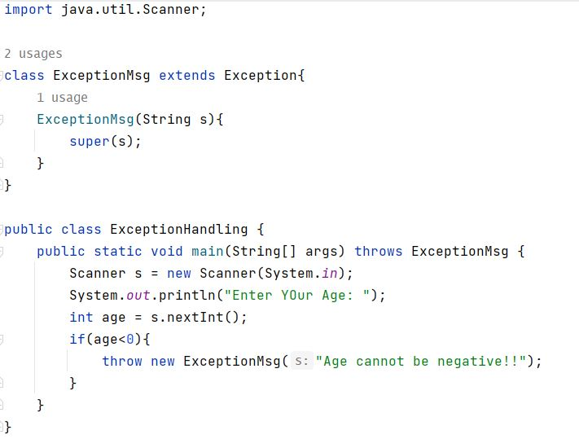

Output:

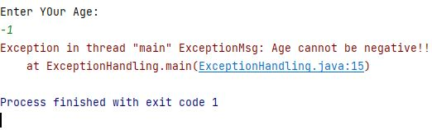

Q2. Write a Program to accept from user throw authentication failure exception if password is incorrect.

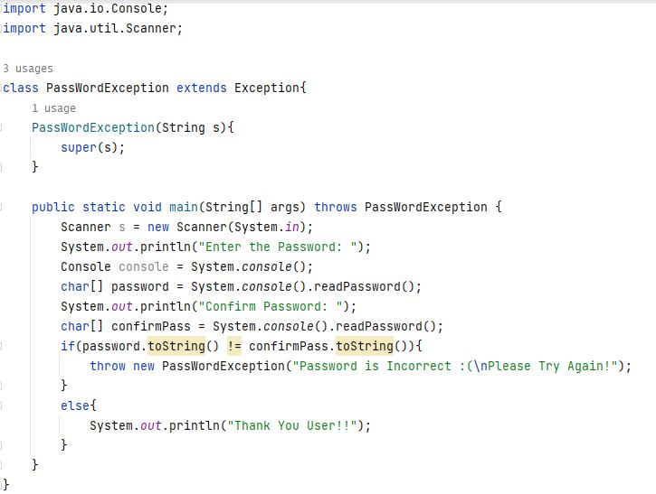

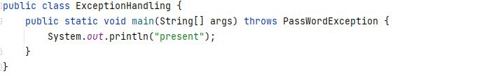

Output:

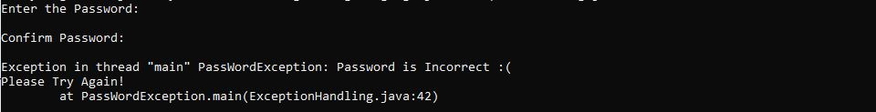

Q3.